Importing Content into Your Course from Canvas Commons
STEP 1  Importing from Commons to your course | - Click on Commons on the left-hand sidebar  - In the search bar, type “GCS_DL2020”  - Find the course you need (i.e. Kindergarten, Math 6, Biology, AP English)  - Click on   - Put a check mark by the course you will import to (i.e. Homeroom or a specific class)  *All elementary teachers should choose Homeroom unless you are departmentalized and teach multiple classes  - Click   - You will see this:
STEP 2  WAIT, WAIT, WAIT | - It takes about 10 minutes for a course to import from the Commons into your Canvas site
STEP 3  Check your Courses for the Import | - Click on Courses on the left-hand sidebar  - Choose your course title  - The district course shell will appear on your screen  - This is now YOUR course. You are the instructor and you will be adding your students. Any discussions, announcements, or content you add will only be visible to you and the students enrolled in your course.
STEP 5  Publish the Course | - With your new course open (the one you just created and imported the shell to), click 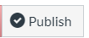 in the upper right-hand corner  - You should now see this: 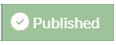  - Your course is now visible to your students
STEP 6  Add Additional Teachers | - Click on the People tab from your Canvas Course menu (left-side in blue writing)  - Click 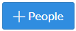  - Choose to add users by   - Type your support staff’s email addresses (for example: EC teachers, SLPs, TA, etc).  - Change the Role category to Teacher from the drop down box (this will allow these people to also add to your course as an instructor)  - Click 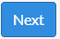  - You will see a confirmation box with the teacher’s names listed. Confirm all your staff and then click 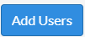
STEP 7  Add Content | - Begin adding content to make the course your own! Resources on how to add content are listed below.  - Ideas to start:  - Write an Announcement to welcome your students to your course  - Start a Discussion for students to respond to  - Add Assignments for your students to submit work
Step 8  Publish Content | - Ready for your students to see the content?  - Click on any resource you are ready for students to see in your course  - Students cannot see any content if it is left 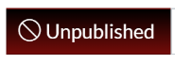
Step 9  Student View | - What to see if your course is working?  - Go to 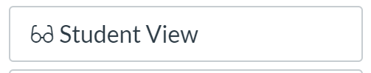 to see exactly what is available to students
STEP 10  Need additional help? | - Click the 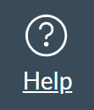button in canvas to search for help resources  - Email/Skype your district content supervisors or the Blended Learning Department

Resources for learning more about how to add content to your Canvas:
- GCS blended learning webinars – links to watch recorded webinars are listed in nightly emails
- Canvas Support Guides can be accessed HERE
- View blended learning’s Canvas Training Guide
- Take the Canvas Self-Paced Course

